L&T Edutech Project

Industrial Internet of Things
Real-Time Clock and Temperature Monitoring System

NAME: R NIKHIL KUMAR
REG. NO:23BEC1416
VELLORE INSTITUTE OF TECHNOLOGY, CHENNAI
GITHUB REPOSITORY: https://github.com/NIKHILKUMAR916/LNT_PROJECT_NIKHILKUMAR_Real-Time-Clock-and-Temperature-Monitoring-System.git

1. Aim
To design and simulate a real-time clock and temperature monitoring system using an ESP32, DS1307 RTC, DS18B20 temperature sensor, and SSD1306 OLED display. The system continuously monitors temperature, displays the current date and time, and generates a warning message whenever the temperature exceeds a predefined threshold.

2. Problem Statement
Industries require continuous monitoring of environmental conditions to ensure equipment safety and reliable operation. Manual monitoring is inefficient and may delay corrective action. This project develops a real-time monitoring system that displays the current date, time, and temperature while providing an alert when the measured temperature exceeds a preset limit.

3. Scope of the Solution
- Continuous temperature monitoring.
- Real-time date and time display.
- Automatic high-temperature warning.
- Simulation using Wokwi.
- Low-cost embedded solution.
- Future IoT cloud integration.

4. Required Components
Category | Component | Purpose
Hardware | ESP32 DevKit V1 | Controller
Hardware | DS1307 RTC | Timekeeping
Hardware | DS18B20 | Temperature sensing
Hardware | SSD1306 OLED | Display
Hardware | 4.7kΩ Resistor | Pull-up resistor
Software | Arduino IDE | Programming
Software | Wokwi | Simulation
Software | GitHub | Project repository

5. Flowchart
Start
↓
Initialize ESP32
↓
Initialize OLED, RTC and DS18B20
↓
Read Current Time
↓
Read Temperature
↓
Display Time and Temperature
↓
Temperature > 35°C ?
├─ No → Display Status: NORMAL
└─ Yes → Display WARNING
↓
Repeat

6. Simulated Circuit (Wokwi)
ESP32 is connected to an SSD1306 OLED via I2C (GPIO21 SDA, GPIO22 SCL), a DS1307 RTC on the same I2C bus, and a DS18B20 temperature sensor on GPIO4 with a 4.7kΩ pull-up resistor to 3.3V.
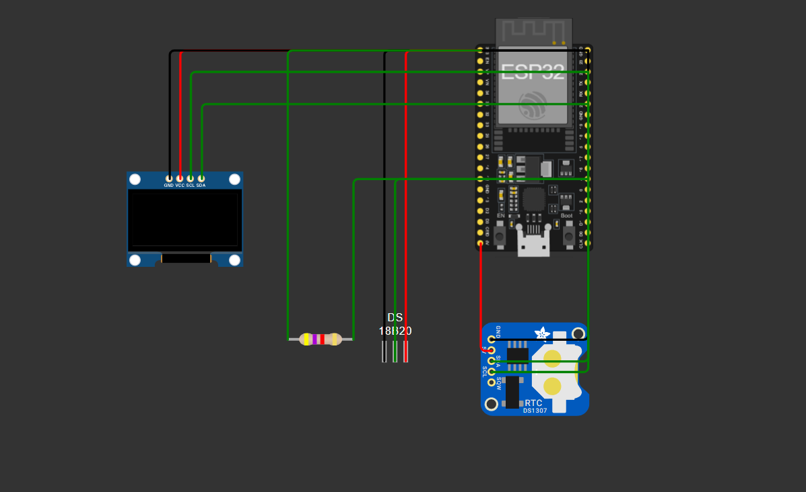

7. Demo
The OLED displays the date, time, and temperature. During simulation, the temperature rises gradually. When it exceeds 35°C, the OLED displays a HIGH TEMPERATURE warning message. Demo video is provided in the GitHub Repository.

